**Plotting Planetary Movements on Price Charts**

**Planetary Price Channels**

Planetary price channels is one way to make the movements of planets visible on the price chart of any stock, commodity or index.

With this technique you can visually see how planetary movements influence the prices as the planets rotate through individual and combined cycles.

Astronomy is the oldest of the sciences and many inventions in mathematics and physics are a direct result of the observations of planet movements in the heavens.

Thus, as the Sun moves 1 degree per day, we equate 1 degree of the circle with 1 unit of price on a daily time bar chart, then look for potential changes in trend for that trading entity in relations to that planets cycle price conversion. Since the Sun moves approximately 1 degree per day it returns to the same place in the CIRCLE (I.E 0 Aries) one year later… hence the cycle of the sun is 360 degrees in 365.25 days. Each planet and moon also have their own unique speed and time cycle

WD Gann used this method in his astro technical research throughout the later part of his trading career. This fact can be viewed in many of his famous hand-drawn charts as we see not only the sun but all planets being plotted the same way

In the following chart we see the glyph of Mars and Jupiter plotted directly on top of this Soy bean price chart

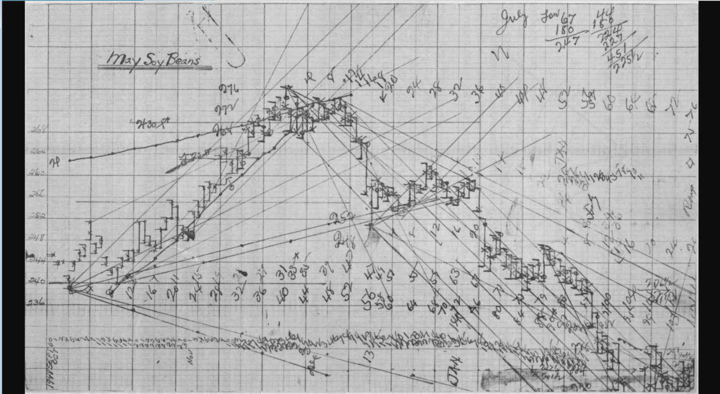

According to George Bayer, “Planets act as beacons on the river of time and attract price”. Both WD Gann and Bayer believed that traders subconsciously are attracted to specific trading vehicles because of the magnetic attraction of that issue. This magnetic attraction not only control the vehicle but also the price and time zones of the issue at hand.

Astrological quotes are given by Gann and Bayer in numerous references to astrology in the Bible and other sacred texts as viewed in “Bible Interpretations” by George Bayer and “Tunnel Thru the Air.” By WD Gann.

**Plotting Longitude to price**

A cycle is equal to 360 degrees, Thus, we take 1 degree of planetary longitude as located on any ephemeris to equal $1 in price (Basic Conversion)

In conversion, each zodiac sign is equivalent to 30 degrees, hence 1 zodiac sign is equal to 30 points in price and 12 signs are equal to 360 degrees.

Aries = 0-29.59

Taurus = 30-59.59

Gemini = 60-89.59

Cancer = 90-119.59

Leo = 120-149.59

Virgo = 150-179.59

Libra = 180-209.59

Scorpio = 210-239.59

Sagittarius = 240-269.59

Capricorn = 270-299.59

Aquarius = 300-329.59

Pisces = 330-359.59

Example,

17 Taurus= $47,

23 Cancer = $113,

11 Virgo = $161,

22 Capricorn = $292

**Natural Energy**

**What are natural energy Dates?**

Over the years I found there are many high volatility periods of buying and selling throughout each month of the year. These periods or dates seem to coincide with non-specific equities or indexes and can be found only through the use of an ephemeris.

Since planets cause many energy spikes for various reasons and many spikes do cause potential changes in the buying and selling action of various markets, we need to know exactly when these periods occur. As we shall see the following periods are extremely important in our investigation and forecasting research.

Once located we keep an eye on each group and use a cluster approach to find the most active periods each month. Especially the ones that come together within a 3–5-day window

With the help of GGU’s ephemeris we can easily locate points by finding dates of the following:

Planet ingress

Planet to planet aspects

Retrograde dates

Direct Dates

Max Declination dates

0 Declination Dates

Crossover dates

Eclipse degree aspect dates

**Individual Energy**

**What are individual energy periods?**

Individual energy periods are dates throughout the month and year in which planetary phenomena strike individual trading vehicles, be it stocks, commodity or indexes

We find these periods by searching for the following:

Planetary fingerprints unique to the market you are trading

Planetary price channels unique to the market you are trading

Planetary price highs and low conversion to zodiac degree

Natal first trade planet location unique to the market you are trading

Planet cycles spinning from low, highs and 1st trade unique to the market you are trading

Progressed moon aspect to natal and mirror points

Rob Giordano