Gann Grids Ultra….. Alan Andrews Lines
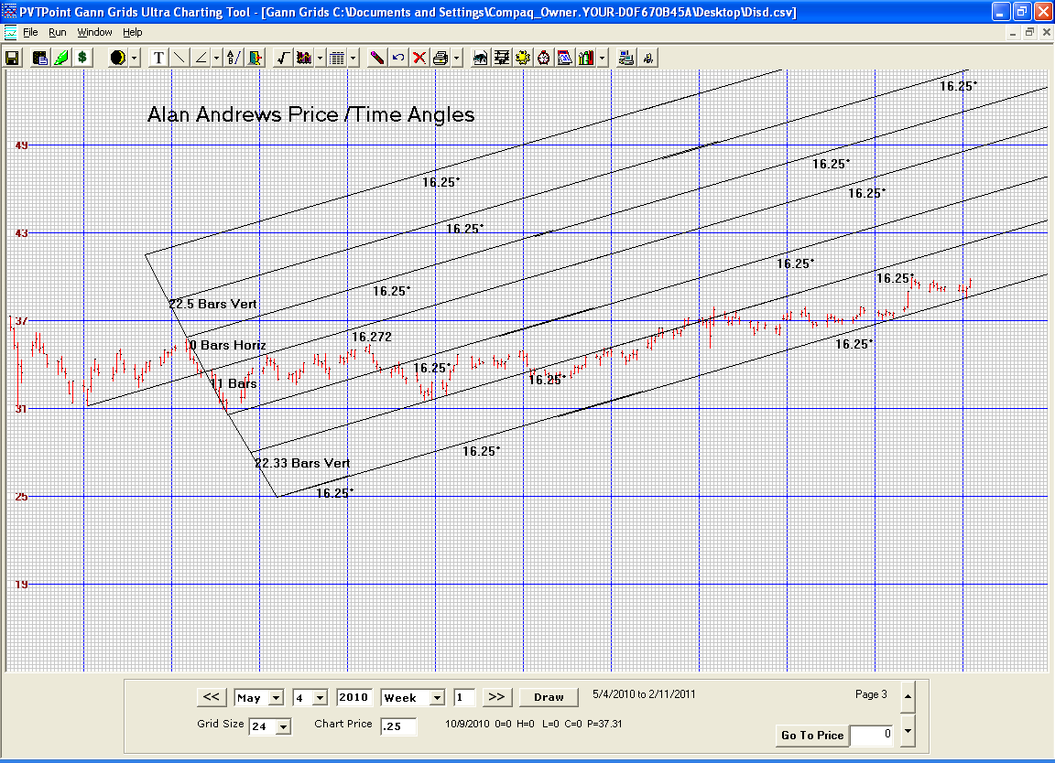

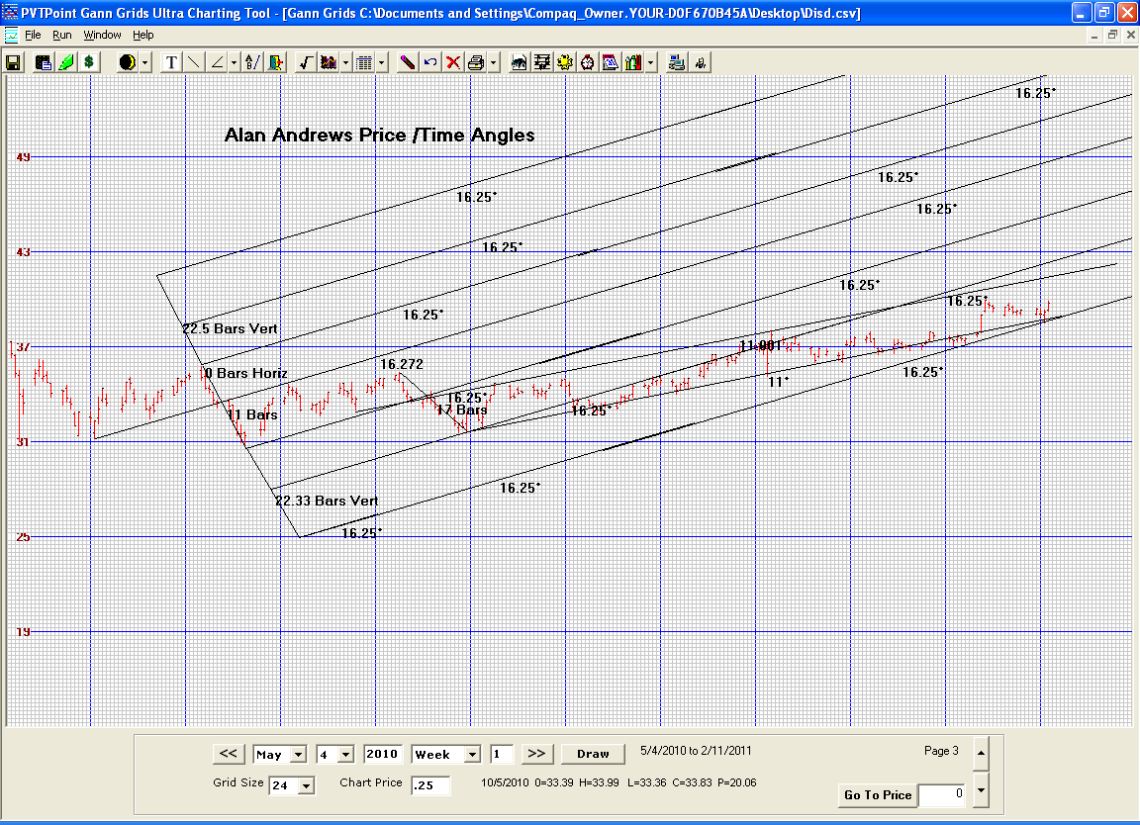

ALAN ANDREWS ORIGINAL COURSE

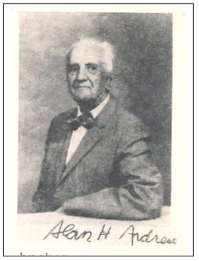 |  | 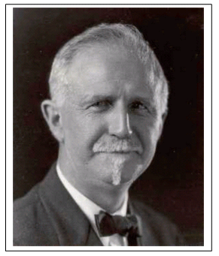

Original Alan H. Andrews Materials
Page | Contents
1 | Introduction
2 | Introduction
3 | Glossary of terms
4 | Rules - Median line, Mini median lines, Action Reaction methods
5 | Discussion about Newton and Marechal
6 | General comments. Includes Marechal's chart.
7 | Drawing median lines
8 | Hagopian's rule - description and charts.
9 | Fan lines
10 | Fan lines and "Horn of Plenty"
11 | Course rules
12 | Drawing median lines
13 | Days of week and pivot occurrences. Sliding Parallels.
14 | Trading off the median lines
15 | Trading example sent in by a course student
16 | Warning lines
17 | Action reaction example
18 | Modified Schiff ML, Schiff ML
19 | Schiff and warning lines
20 | Median lines trading example
21
22 | Action Reaction rule
23 | Median line trading example
24 | Action reaction lines trading example
25 | Zero to Three Line (0-3) discussion
26 | Diagram for the 0-3 line discussion
27 | Action reaction lines trading example
28 | Use of Action and Reaction lines
29 | Profit examples from trading median lines
30
31 | Action Reaction rule examples using 0-1 CL
32 | Action Reaction and (3) CL lines
33 | Action Reaction with 0-4 center line example
34
35 | Action Reaction example (chart not completely cleaned - very difficult to see)
36 | Action Reaction example , including usage with RSI indicator
37 | Expanding Pivot Formation
38
39 | Action Reaction example and discussion. How to draw lines
40 | Action Reaction step by step working of projection for next pivot
41
42 | Prof. Anderson's Five pivot rules (on web site pg 42 contains pg 43)
43 | Non median charts - waves
44 | The examples for AR 42 - waves
45
46 | Action reaction lines trading example
47 | MPLs and multiple lines converging
48 | EP example (expanding pivots)
49 | EP example (expanding pivots)
50 | EP example (expanding pivots)
51 | Expanding Pivots discussion
52 | Action Reaction example
53 | Median line example
54 | Median line example
55 | Median line example
56 | Median line example
57 | Median line example with head and shoulder pattern
58
59
60 | AR 9
61

THE FOUNDATION FOR
ECONOMIC STABILIZATION
Dear Mr. Unger:
Welcome to the FFES (Foundation for Economic Stabilization) Case Study Course applying principles of mathematical probability to the production of profits from prognostication.
The old Romans were wise enough to know that things change and fluctuate. They therefore recognized that the best way to know what would probably happen in the future was to study how changes took place in the past. To symbolize this, their two headed Janus was their chief deity with one head confidently looking to the future as the other head had studied the past.
While it is true that few things are certain to happen in the future at a definite time such as the time that a certain person will die in the future, this mathematical probability has made tremendous profits for the insurance concerns that use it, as well as similar profits for investing individuals who employed it.
What are some of the important profit making principles that you are now about to learn to use. One is the application to price fluctuations of Newton's law of physics to which the late Roger Babson attributed his fortune of over $50,000,000. The Action and Reaction Rule that states these are equal and opposite. Another is how drawing a single line will enable you to know where the price of any stock or any future is now headed and the probable time it will reach there. Then there are principles that enable you to switch positions so near to the turning points or pivots that start each new trend, that you may be constantly either long or short making money whether price is rising or falling. Also in each weekly letter on the right hand column you'll see some abbreviations that are headed "reasons for actions taken". As a course member now you'll have the glossary of these abbreviations so you can now verify on your own chart that every change of position from long to short has a scientific reason. Have you ever seen elsewhere anyone making such information available? Many of our members have taken other courses and we hope you'll find as they have that this one of yours in the best.
Besides the above principles that are unique to this Course you'll also find what we have been informed are better ways of using other well known methods, and as an example we've added channel lines to the popular moving average method in a way that you'll find helps eliminate some of the whip-saws the usual moving average followers frequently find troublesome. Then various members of the past have added improvements that bear their names, as you may do in this wide open field of probability applications to price fluctuations.
Your glossary of abbreviations is enclosed so that you may soon get the meaning of the abbreviations that summarize the rules. Other Course studies including some recent Course letters will follow soon.
So many investors have doubt as to the possibility of constantly predicting when and where prices will turn. Therefore the Marechal Chart is a good starting point for your studies as he was one of the first to use mathematics to show what the DJI would do during the coming 20 years from the time he copyrighted his chart.
Feel free to write whenever you have questions and am confident you'll be happy you've joined this wonderful group of investors who want to become "Good Stewards" as in the parables in Luke 19:11 on and Mathew 25:14 on if my memory is correct.
You investors are the life-blood of the economy. Without you there's be no banks, chains or factories, etc. where a person could choose jobs, nor would the government be able to
Sincerely,
Alan H. Andrews, Trustee FFES.

THE FOUNDATION FOR
ECONOMIC STABILIZATION
Alan H. Andrews Trustee
5738 S.W. 53rd Terrace
South Miami FL 33155
You will find enclosed the first study of the Course concerning the ML (median line) Method. This enables you to know where the trend of anything that fluctuates at random is headed. What everyone wants to know is where the latest trend is headed, and where the next pivot (P) will be from which the reverse trend will start.
The probability of the next P being at the latest ML seems to be about 80%, and even without any additional rules that enable you to be constantly either long or short! profit potential of this simple rule is tremendous for you.
Although Marechal never left us exactly how he was able to predict twenty years in advance what his copyrighted chart showed the Dow Jones Industrial Averages would do, you can draw in the MLs from each P bisecting the distance between the 2 latest alternate Ps, and see that nearly every time the new P occurred when prices met that latest ML. You'll also see that on the right hand side of his chart prices were too strong to drop to the ML that started from the high in 1945, which always signals that a big rise is ahead unless the next trend fails to reach the new ML. This cancels out the prior signal and signals a big move contrary to the big move previously signaled. And as there was no contrary signal after prices failed to drop to reach the ML from the high in 1945, you could be confident of realizing a big gain from your long position taken as soon as prices crossed the parallel to the ML from the high of 1945. You draw this parallel from the third top that the ML was drawn half way below on the distance to Previous P.
You can now tell from the enclosed Glossary what the abbreviations mean, in the right hand column of each weekly letter. This enables you to understand the scientific reason for each new position taken based on simple geometry. When you change a position your new methods enable you to be one of the few persons who knows how to be constantly either long or short, in this way you make profits after each rise and fall that follows the rise. You may be whip-sawed a few times but if you get you order in before the market opens the next day, should prices move against the position you have just taken, your losses will be small and often show a small profit.
You will see all this after you've done some "paper trading" which you should start on right away showing on your chart where each position was taken. You should concentrate on the ML method applying that even if you have had experience with other methods. For we learn best by concentrating on one thing at a time. When you have a question mark where the question arose and send me a copy of your chart that should also list our profits from the two contracts you take each time you change position. When you write out your question leave a space where my answer can be written and mailed back to you.
After you see that your paper trading has made well over the 100% profit rate, it will indicate you are ready to learn the Action and Reaction Method to which my friend the late Roger Babson attributed his fortune of over $50,000,000. Then after that let us know and you will be sent the rest of the Course Studies.
Sincerely.
Alan H. Andrews, Trustee FFES.
Glossary and Abbreviations of Course
A/R | Action Reaction Rule
Bears | Persons expecting market to go down, or who are "short" the market. From the French Proverb about selling the bearskin before catching the bear.
Bulls | Persons expecting a rise in prices
B | Buy
Bottoms | Low pivots on a price chart
CL | Center line about which moving averages fluctuate or the line used in A/R
DL | Daily limit for price fluctuations
D | Down, usually as applied to trend, as in DT meaning down trend. DT is usually indicated by lines through top pivots, showing the slope of drop in prices.
EP | Expanding pivots where price swings get wider toward tops of a trend.  IEP means inverted expanding pivot found near end of a DT.  SEP means skewed EP where swings get wider but not about a level line as in EP, IEP means swings get wider about a sloping CL.
ER | Elliot's Rule
FL | Fan lines or radiating ribs as in the Courses exclusive "Horn of Plenty" study
FND | First notice day, the day holders of positions are notified of delivery due under each terminating futures contract
GAP | Denoted by G as in GU meaning gap up, or GD means gap down. Shown on bar charts when no price on today's range is opposite any of Yesterday's range. Technically and empirically the price at one extreme of a days range may be opposite the extreme of the next day's range, and still have the properties of a true gap.
HR | Hagopian's rule found only in this Course
Hedge | To take insurance of some kind against loss. E.g. sale of a future by a producer who thinks prices will be lower when he is able to deliver.
ITL | Imaginary trend line used by Morton's Rule found only in this Course
MA | Moving average
MIT | Market if touched means that your order is to be executed at market when a specified price has been reached even if only the prior orders to yours were executed at the specified price.
ML | Median line, & MLH means median line parallel. Used to signal change in trend when price touches or pass past these lines, under specified conditions.
MPL | Multi-pivot lines, lines that pass through 3 or more pivots. Used as CL about which to measure A/R
MMPL | Maximum MPL, the line on any chart that passes through the greatest number of P. used as a CL it has the highest probability in measuring A/R
OI | Open interest, the number of contracts open in a future at a given time.
P | Pivot, a turning point. It is the extreme on a bar chart where a change in trend takes place. Knowing where Ps will occur is key to profit from fluctuations.
P-L | A line from the Peak of a price swing to the Low. L-P from Low to Peak.
R | Reaction line, the equidistant line from a CL that the Action (A) line is opposite. This law of physics stated by Newton that Action and Reaction are equal and opposite was first applied to prices by your Course Director's friend the late Roger Babson, who attributed his earnings of over $50,000,000 to this law.
S | Sell
SH | Sliding parallel
W or WL | Warning line parallel to MLH and same distance from MLH as MLH is from ML. Probability of pivot at or near WLs. There may be several WLs all equidistant, and several MLs and CLs such as RML, meaning reverse ML or MPL and (0-3) and (0-4) or (4) both minor through closes, or major through end of ranges.

FFES CASE STUDY COURSE RULES
Median lines and MLH: the MLs enable the user to be one of the few who can tell where the prices are headed, and the place they will reach about 80% of the time, and when approximately that place will be reached. Slopes of alternate MLs of comparable length indicate the trend.
When both recent MLs slope in the same direction the trend is strong and price change rapid. A reverse ML is formed when 1ML2-3 is exactly reached at P4, and is a reliable CL for applying the AR method.
There is a high probability that:
- prices will reach the latest ML
- prices will either reverse on meeting the ML or gap through it
- when prices pass through the ML, they will pull back to it
- when prices reverse before reaching the ML, leaving a "space", they will move more in the opposite direction than when prices were rising toward the ML.
Prices reverse at any ML or extension of a prior ML.
Frequently, after crossing a lower MLH, prices continue to rise along the MLH before the further drop that was signaled by passing through. So here you can use a sliding parallel through the bottom of the range of the most recent day as a sell signal if prices drop through that SH.
MLH are places beyond which each day you place a buy or sell order before the market opens the next day if prices pass through that MLH. MLs between P2 and P3 can start from nearby or more remote P1s, and prices tend to reverse at each of these MLs. The distance of each MLH from its ML is the distance of the next warning line (WL) from that MLH. When a second "space" reversal negates a previous one, there has been a "shake out" that signals a larger move in the opposite direction.
Mini median lines (MMLH): Use the MMLH as the buy/signal when you expect a reversal because of a P5, or because prices are at an RL, WL, major ML extension, etc. Also use MMLH as a stop loss right after entry.
If prices cross an MMLH and then move along it, enter when prices reverse by use of an SH.
In some markets drawing MMLH from end of ranges is best to reduce whip-saws, but use closes to draw these MMLHs between usually.
Converging lines that meet prices have high probability of trend reversal.
MMLH lines can be drawn through the daily range after a gap.
Two to four days is usually a maximum between 2 and 3 for an MML. P1 can be 1 day or more back from 2 and 3.

ACTION/REACTION are equal and opposite:
CL can be 0-3.0-4, Reverse ML, MPL, 2G, MA, MA Channel Line, 2P, Peak to Low, Low to Peak etc.
Normally use a down sloping R line to call a sell point, with A line measured through a bottom. Exception: still using Dt R line to call the sell point, when CL is a 0-3, the top seems to work for the A distance, as well as the bottom.
When prices pass through R lines, it often drop back as with MLs that are passed by prices, but signals probability of further move in direction before the pull-back.
Since each gap is 2 Ps they can be used for A points. When MA is used for CL, use closes for measurement above and below MA. Hagopian's Rule applies to R lines. The longer the CL the more reliable it seems.
Case Study Course on Price Fluctuations
Sir Isaac Newton and George Marechal
Of the two kinds of change in the Universe, flowing change and random change, we are indebted to Newton's invention of the Calculus that enables us to find out in advance the conditions that flowing change will produce in the future. His discovery of the natural law that Action and Reaction are equal and opposite in the field of physics also has been applied in the Course to the random changes of price movements in free markets. This application of the Action-Reaction law enables you to learn in advance where the probable reversals of price trends will come in the future. We owe this application to the late Roger Babson, who credited this law as the basis for his fortune of over $50,000,000.
When we speak of any scientific law, we mean a statement that a relationship has been observed among certain given conditions. We mean "if these conditions now, then those conditions will follow, and can be expressed mathematically". We have "order" through which we can know the outcome from these conditions. We can therefore take advantage of this knowledge, and thereby progress and profit.
So Newton was one of the great discoverers of this "orderliness" that underlies all of the Creator's work, even if we are often slow in discovering it. Newton's Laws therefore as stated above, have benefited the users in both flowing and random changes.
The definition of randomness implies that future conditions are unascertainable, because there seems to be a lack of order underlying such change. Such has been the almost universal belief, still prevalent with most people as far as price prediction is concerned.
Marechal, also by mathematical methods of his own was the first to demonstrate that there is also order underlying the so-called random changes in price fluctuations. No professor in any University, no government economist, has ever been able to produce a similar chart showing as Marechal's famous chart, copyrighted in advance, what the Dow Jones Industrial Stock averages would do 18 years ahead. As one of many other examples of this mathematical orderliness regulating the flow of stock prices, the writer received from this remarkable man now approaching 90, several months before President Nixon's election, an accurate prognostication of what the DJ Industrial Averages would be the day after Nixon's election.
Many others such as classmate Dewey's Foundation for the Study of Cycles have shown the "order" underlying stock and future prices. For example the recent rise in price of Copper futures was predicted by the cyclical studies of that Foundation several years before the advance took place.
So now and during each of the past ten years your Foundation for Economic Stabilization has presented this Case Study Course on the predictability of prices, summing up the results of thirty years of research and inquiry among successful investors. By the use of these Course Rules never before published except by your Foundation, you as a Course member will have an advantage over others without knowledge of these Rules.

Alan H. Andrews, Director

THE CHART NO GOVERNMENT ECONOMIST, NO COLLEGE PROFESSOR
HAS ENOUGH KNOWLEDGE TO EVEN APPROACH, OR COURAGE TO
TRY TO DUPLICATE. George Marechal's Chart.

If one is posing as an expert looking for a government job or research grant, and another person with superior knowledge might be a possible competitor, the policy of ignoring superior accomplishment is frequently adopted. "Sweep it under the rug" policy.
Fortunately there are real experts like Garfield Drew, and classmate Edward R. Dewey of "Foundation For Study of Cycles" fame who are not afraid to call attention to the person who can outperform the rest of us. Mr. Drew whose book "Modern", rather "New Methods for Profit in the Stock Market", has this chart. He introduced Marechal to me at a dinner and seminar I was giving at the Beach Club at Craigyville Beach. And that was the beginning of a friendship of several decades wherefrom Mr. Marechal has provided me with advice of coming price movements whose accuracy has never been equaled by any of the many forecasters whose services I've engaged. And Mr. Marechal's forecasts were freely given, to me and a few of his friends.

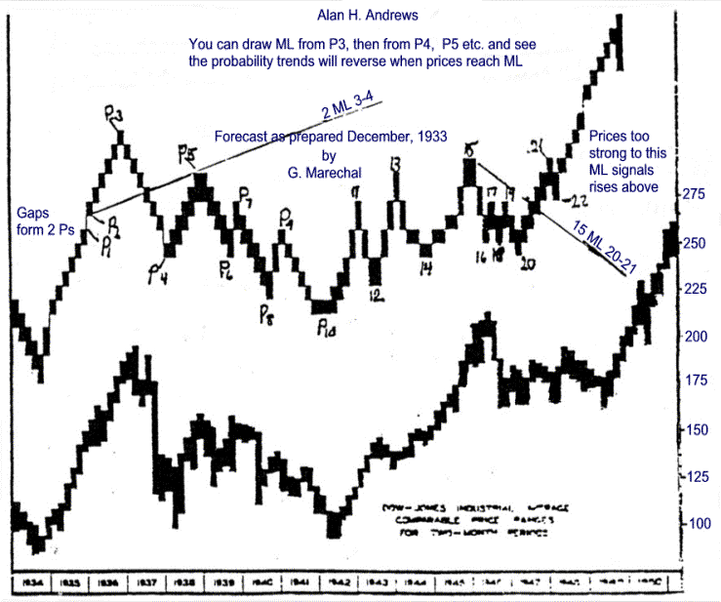

The Median Line Method for Foreseeing Trends
Below is a stock market index which you will find valuable in anticipating what your stocks are going to do, whether they will continue to rise or fall and how fast. These are the facts everyone wants to know, and this method has not been revealed before to the best of our knowledge. Those who acted on this method got out of their stock either at the end of February or April right near the top.
Start with any pivot such as low pivot 1 and draw a line bisecting the distance between pivots 2 and 3. On April 1st all the information you had as to prices ended at pivot 3. This bisecting line is always a test barrier, whatever pivot you start from. If prices fail to rise above the barrier, the rise is finished, as turns out to be the case at pivot 4. Next, as time passes and new prices develop a pivot at 4, start at pivot 2 and draw a line bisecting 3 and 4. You will see that this dash line is steeper down than the upslope of 1-4. So this is like a vector diagram of forces showing the trend will be steadily down along the dash line until medians point upward again. So continue to draw these lines so you may get in near the bottom.
Similarly in a rising market, you will notice that the fastest gains are always made when bisectors from higher and lower pivots point in the same direction.
This method is superior to the Moving Average Method of recognizing Trends in that there is less "whipsaw", and closer positions to the bottoms and top pivots are possible. One reason for this is that there is a probability that when prices so pass through the bisecting lines, they will return to it before continued movement in the newly indicated direction. (Rule #7 - Penetration Rule)

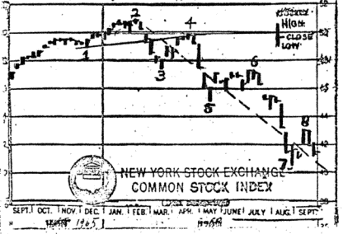 | Alan H Andrews,  Director  copyright 1966  Further details later  and in Seminars for members  of this Case Study Course  THIS IS A VERY IMPORTANT  PRINCIPLE SO MAKE SURE  YOU UNDERSTAND IT

Hagopian's Rule: When prices reverse trend before reaching a line at which probability indicates such a reverse could start, proper action may be taken in buying or selling, as soon as prices cross the trend line they were moving along before reverse. (Mar. Corn, e.g.)
A large countermove is indicated and confirms the first action as above, when prices cross the first Trend Line sloping away from the original line. This line may be a trend line, a median line, a reaction line, or a moving average line. The rule still applies.
For example of May Soybeans chart, UTL2-4 is the first UTL to slope away from 2ML3-4, UTL1-3 the first on Pork Bellies, DTL2-4 and UTL5-7 on Sugar, and UTL2-4 and b-c and c-d on Wheat. The other TL that can be drawn from the low pivots, parallel or slope toward the original "Barrier Line", whichever type of line we choose to measure from.

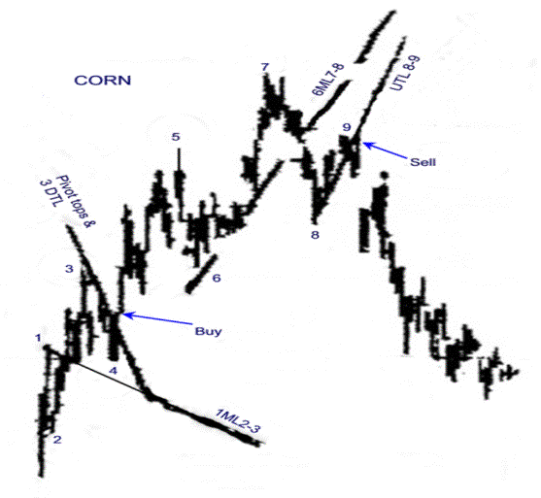
{AR 8 part a}
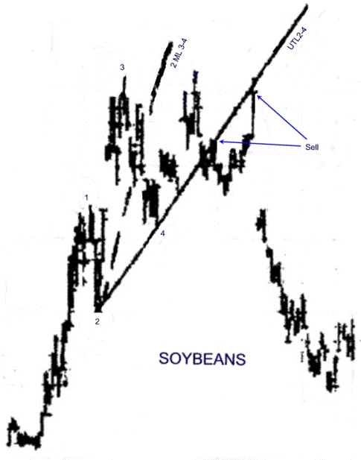
{AR 8 part b}

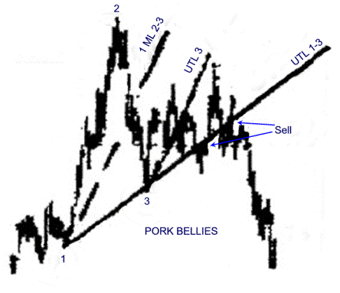
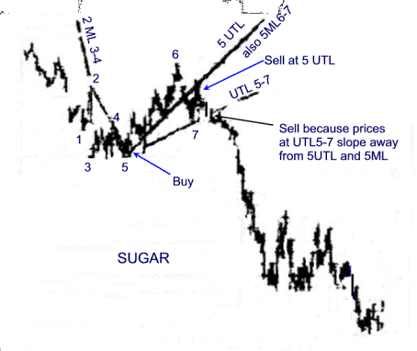
{AR 8 part c}

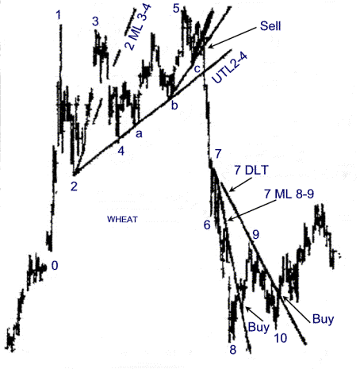
{AR 8 part d}

{AR 9} 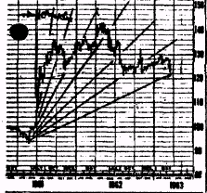For those whose tuition is fully paid we show a weekly price range chart for Winnipeg Berley nearest Futures, and the 3 steps in practical analysis of such a chart to assist in realising gains.
(1) we begin to wonder about the orderliness of price movements in stocks or in commodities, we note that whenever there is a sudden drop or rally, it is a signal that a series of 10 degree T.L.s (Trend Lines) can be generated as drawn in on this chart, each a "Horn of Plenty"
(2) Gathering data and taking measurements on numerous active charts shows that these drawn in T.L.'s are frequently helpful in determining the pivots (buy and sell points).
(3) To find out just how orderly and useful these relationships are, we note that the rise can go on without any concern to those with a "long position", provided the price movement stays within the first two 10 degree lines as shown.
Upon crossing the 20' (degree) line, prices frequently drop to the 30' line, giving opportunity to add to one's long position, or "pyramid" for possible resumption of the rise along or within the 40' line. Frequently, crossing the 40' up-trend line, or UTL means beginning a substantial DTL (Down Trend Line). This is very frequently true if this downward counter move is preceded by a sharp vertical peak. The top of the price movement shown here is a rounding top, as named by Chartists.
Obviously the slope of the TLs depends upon the relative proportions of the coordinates used by the maker of the chart. But by counting how frequently these pivots occur, and the exactness of fit for each particular stock or commodity charted, indicates the reliability of the probability for their reoccurrence. And action can be taken when the odds are strongly in your favor.
The words above that are underlined are all terms used in the study of Probability. Reference to the chapters dealing with Frequency, Reliability, Exactness of Fit, in Monroney's "Facts from Figures", go into their meaning and application in detail.
Upon request you will be supplied with Stephen ???? Stocks or Horsey's Stock Picture if you wish to apply the various aids provided by this course to particular stocks that you own or are interested in. Also you will be supplied with Dupont's Chronoflex if you wish to fasten this transparent drawing paper over your charts in order to avoid drawing-in the various lines and measurements on the charts directly.
We have also designed several devices or tools, in the use of which protection is provided through the US Patent Office, which will make it easy for you to apply the principles of probability which we have developed relative to price movements. These methods will enable you to continue to make gains similar to those made by others in this course who followed the indications properly.

Alan H. Andrews, Director
copyright 1963 by
Alan N. Andrews
The NY Silver chart below was drawn by a new member, Mr. Edward Palm applying the Foundation's "Horn of Plenty Study". Mr. Palm has made, and is making an exhaustive Study of all available scientific Courses relative to Price Prediction, and was before going into business for himself the writer of the periodic letter sent to customers of one of the largest Commodity Firms.
The lines below from the "Horn" method illustrate how prices fluctuate along these regular geometric 10 degree radial lines as well as between them.
Another Course member has written us that he has made very satisfactory profits from the "Horn" method and it is apparently his favorite course method.
It seems natural for each person to select a method that appeals to him. One of our friends who is one of the County's largest Traders told the writer that he liked the Moving Average Channel line method for although it didn't get him in always at the bottom or out at the top, it did give him profits from the long trends. However this man was constantly on the lookout for other successful methods. For there may be frequent times when other methods can prevent some of the "whip-saws" common to side wise movements of prices in their fluctuations.
You might like to put a piece of tracing paper over this chart and start your radial lines from the low on the last of November 1973 at the 275 area and see the similar fluctuations along and at these radial lines. Such practice certainly gives the investor a "feel" of the market.

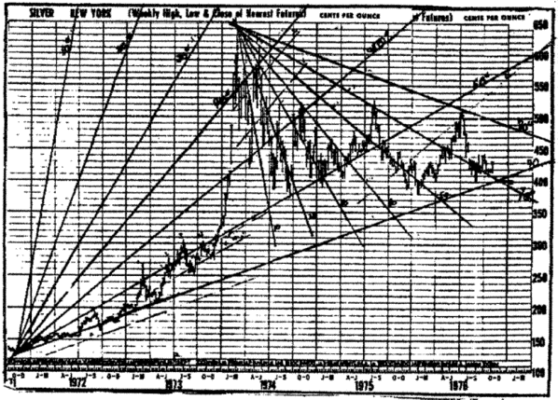
SOME COURSE RULES APPLYING MATHEMATICAL PROBABILITY
TO PROFIT FROM PRICE FLUCTUATIONS
Rule #1. Where prices are always headed Rule. You course members are among the fortunate few to be able to draw a straight line and know that prices are headed toward that ML. Very few investors have ever applied this ML principle of statistics to price fluctuations, and we've never seen this in any books on investment. So very few know that prices are always headed toward the newest ML.
Rule #2. The Rule of coming opposites applies all through life. E.g., "Blessed at they that mourn (when the price of their stocks fall), for they shall be comforted." For the value of their savings that they had put into stocks will fluctuate up again. And find the "Wes Usto" also in the New Testament and in prices.
Rule #3. "Turn your mind about," or "Rethink, for all good is at hand." We should mentally prepare ourselves for the coming reversal in prices, and other affairs. Here's one way for example, that you members who know the ML rules can use: When prices are skyrocketing upward, we do this preparation by thinking "If prices pivoted here today at this price, I'd draw a new ML bisecting the distance between today's price and the price from which the rise started." And we know now that if this is a Major Pivot, prices will fall rapidly to this new ML. Profits from such drops are big and quick.
Rule #4. Rule for anticipating major P's. If after a decline you can count four previous P's, the fifth one is highly probable to be the one from which a new trend starts.
Rule #5. Rule for easily detecting the major P from which you can make a quick, big profit is to watch for the EP , IEP and SEP formations.
Rule #6. The other reversal rule is that prices tend to reverse at or near any ML, as well as at any extension of each ML. And also at any MLH or extensions of MLH.
Rule #7. The Penetration Rule is that whenever prices gap past, or plunge through any ML, there is a high probability that they will quickly return to it temporarily, and then resume the trend they had before they gapped or plunged through.
Rule #8. Price Failure Rule; When prices fail to reach the ML as shown by a space between the P of reversal and the ML, the probability is that this price reversal will go further than it did on it's approach toward the ML.
Rule #9. The price failure rule is negated when the next price trend is also a failure in reaching the ML. This is almost invariably a signal (a shakeout) of a big, fast move in the direction indicated by this last "space."
Rule #10. Reliability of ML and (3) as CLs on weekly and monthly range charts is good for the MLs but as significant Ps may be hidden in any weekly range, you'll have to make allowance that this happens.
This chart shows you how to draw the Median Lines (ML) from each pivot (P). You start the line from each pivot and bisect the distance between the next two pivots extending the line for the next pivot will 80% of the time be at or near that ML. And when late prices meet this ML extension as shown in the months of September and November you see that you will have price fluctuations around the extension of the 6ML7-8. This enables you to be one of the few investors who always know in advance the probable place where a reversal of the trend will come.
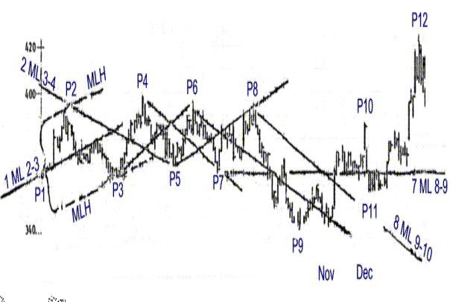
You see that a parallel has been drawn from Pivot 2 and another from pivot 3. These are abbreviated with Capital letter H since that letter has two parallel vertical bars. So when you want to distinguish them from other lines you would letter them 1MLH or 2MLH, the numerals refer to the number of the pivot from which that ML is drawn. When prices drop below that H that slopes upward it signals Sell. And when prices rise above its extension the signal is Buy. And the signal is the same when the ML and its H slope downward. A profit is probable if you reverse positions when prices meet the ML. Even when prices pass beyond the ML a reversal back to the ML is probable even though that penetration predicts the probability of a further move of prices in the same direction as when they penetrated that ML.

Study WHAT DAYS OF WEEK Ps FALL ON ! Here are a few for you to add to. You'll see on your March Soybean Chart that either a P or a gap (which is 2 Ps), since June 1st has come on every Monday except 4 days and a holiday. This includes all minor Ps of either ranges or closes. A P fell on every Wednesday except 4 plus 2 holidays. When no P on Wed it came 3 times on Thursday and the rest on Thursday. On Hogs all Mondays except one and a holiday or two. Major Ps about half come on Monday.
USE OF MONTHLY RANGE CHARTS & SLIDING PARALLEL: The enclosed Egg Chart that was sent you before to have as a confirmation of the long term probabilities as indicated by the short period range charts is a good sheet the practice the use of ML, MLH, SH.
You'll see the ML starting from Aug. 1960 and after prices pass through the lower MLH signaling that lower prices are eventually coming, prices continued to rise for 4 months along the lower MLH as they frequently do. But if you draw the little dash line (SH) you see your sell signal when prices drop through in August at about 37 for a nice 7c drop during the next 4 months. We've drawn another sample ML from that Aug. 1961 top and a SH through the top of the range in May of 1962 with the buy signal when prices rise above it. You can see that when prices drop through the MLH of this ML from Aug 1961 they rally, and the rally from this MLH that starts in Dec. 1964 at the 26 buy area is profitable. Use tracing paper and fill in the other with B & S points and add up your paper profits.

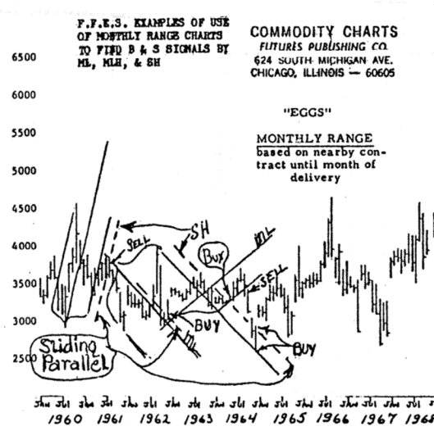
All fluctuations in prices are changes in the price level about the ML first presented to investors in this Case Study Course. Each ML starts from a pivot or turning point in trend and is drawn so that it bisects the distance between the next two Pivots (Ps). Then a parallel is drawn from the second P, and another from the third P, as shown on these charts below of leading Broadcasting concerns listed on the stock exchange.
On the ABC chart below you see drawn the ML, the two parallels abbreviated MLH, with UMLH denoting the upper one and LMLH the lower. Also note the minor ML that starts with the low in Oct.1972, bisecting the distance between the high in Nov and the next low. When prices at the close on the second week in February drop below the LMLH at 39 during the second week in January that is your signal to sell short. Also another such signal was the gap-down in the third week in Jan. Further confirmation of the correctness of this short sale is given when prices drop below the major MLH the last week in Jan., at 35 area. By end of '73 price had dropped to 19. So gain was about 33% in the 4 months shown on chart below or at rate of 100% yearly. While the mathematical probability of prices reaching the latest ML is high, you'll note prices here couldn't reach it, a sure signal of a big drop ahead. Capital Cities chart and the others use the same method to show you where to buy, via passing the MLH, and on a "break-away gap".

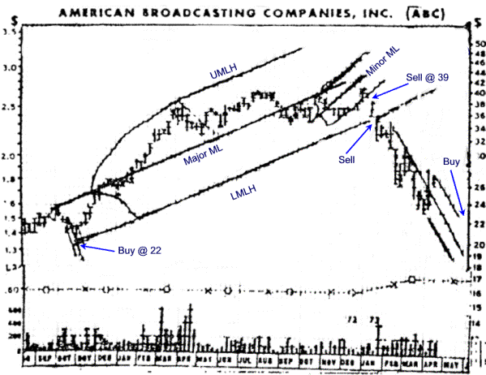

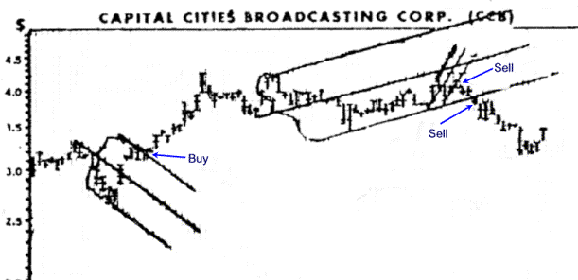
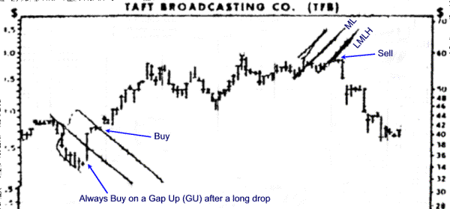
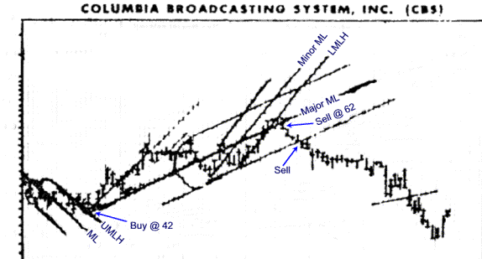

Case Study Course Method of use of the Mini Median Line (MML) and parallel (H) lines, to determine entry and exit points enabling you members to be constantly either long or short, thus making profits on every up and down fluctuation on any stock or any future. Use of the MML method at P5 or P7 is especially important after probability shows end of trend is near.

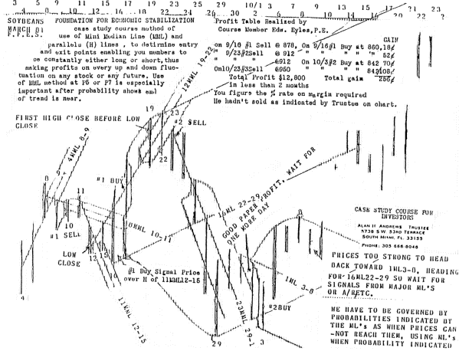
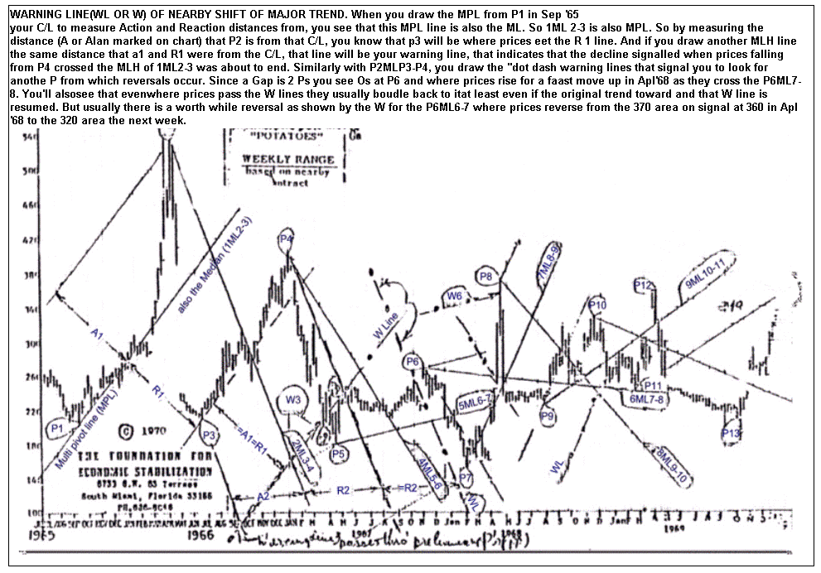
Median Line #2: From a P3 after a change in Trend draw a line bisecting the distance between P2 and P1. Then using this ML#2 as a CL draw the usual A and R lines in order to see the strength as indicated by the ability for prices to recover back to each R line that was past. Relative strength is also indicated by recovery to the latest minor ML after each drop or nearness to the latest ML.

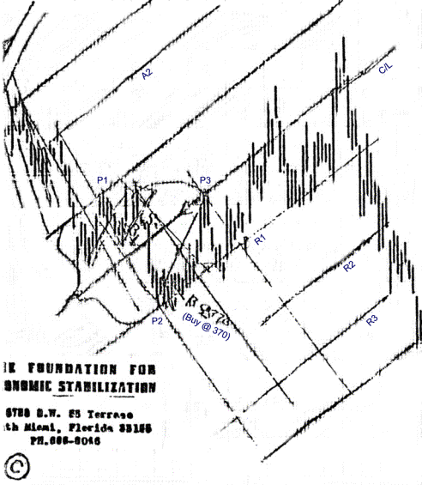
Below is a modified Schiff ML. As you can see the starting point is not under the top close of 12th September, but at the half way mark of the line sloping from that high to the low close on Oct. 23. And it bisects the distance between the close of that date and that of the next P of high close on Nov 13th. You notice that the low on Dec. 16 reversed the trend when it nearly touched the modified Schiff ML. Next you see that there is always a reversal or gap when prices reach any of the WLs. Note that the usual Schiff ML calls the first low P on Nov 28 and the modified ML indicates the low area on Dec 16th. But prices tend to Pivot when meeting any of these ML. But doesn't the slope of coming trends more closely follow or H that of the mod.ML.

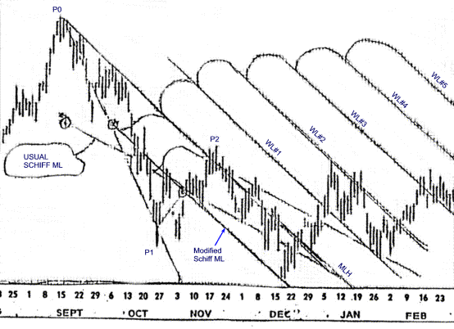
Where only Schiff MLs were used on the July Lumber 1982 weekly range chart you see some profit making signals by drawing the H and the WLs from the usual Pivots of the Schiff MLs. And as Mr. Schiff told members "use the weekly charts for overall picture but zero in with the daily charts".
Notice the probability that there will be a good profit from the reversal each time prices reach an H or a WL as well as when prices again reach the original ML. For example prices climbed back to the 7 in 2 weeks to the Schiff 5-6ML whereas if the ordinary ML had been used there would not have been any sell signal due to prices reaching the ML as they did at 7. The dotted line is for the H or the WL, and the dash line for the ML. Notice how prices dropped back to the parallel of that nearly horizontal H from 7 for a one week rise signaling a big drop ahead which carried prices below WL#1 almost to WL#2 and then a made a 5 P Elliot rise to above the horizontal H of Schiff ML5-6 and then started a new ST of 5Ps from 9 to 10 reversing at the WLs repeatedly, for good profits each time.
There was not space enough to draw the other parallels and ML lines but if you put a transparency over this chart and draw those lines in, you will see that they too provide signals for additional profits. So remember to use these Weekly Range charts to increase your profits by using the Schiff MLs.

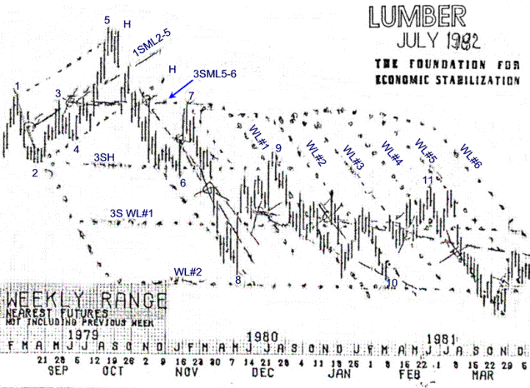
Lack of faith, inability of unwillingness to believe, a search for reasons why to avoid taking action seems to be the reason that more people failed to avail themselves of the hundreds of percent profits they should have been making since December 1972. Below are a few of the charts showing the exact dates and prices where purchase or sales were indicated by the methods presented to you only in this course. Remember what Mr. J. P. Morgan said, "prices will fluctuate". There are even quicker profits ahead for you on the "down" side after these rises are over.
And those of you who haven't the time available to give to commodity trading can use the principles just as successfully to make 100% plus yearly from your stocks. Or you can follow the "orders indicated" and positions of the weekly Course letters and just phone your broker. But be sure you give the orders, and "don't let him advise you" is the advice given by nearly every successful trader.
You figure the percentage profits on margins of 10% of the total value of each contract. Perhaps next week we'll find time to give the percentage gains made by all who acted on these course signals.

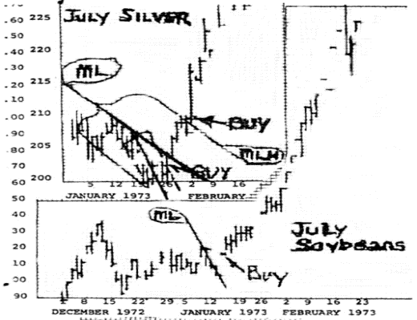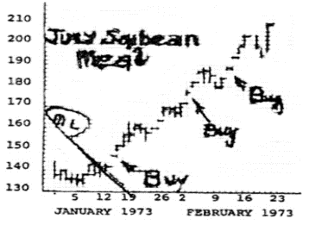
part a

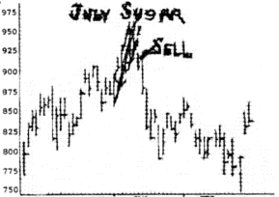

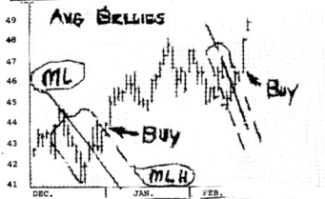

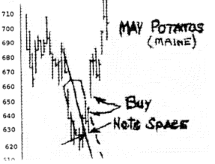
part b

Case study course on applications of mathematical probability and morphology to prices

The Action and Reaction (or AR) Rule: This Rule was first applied to price trend changes by the late Roger Babson. He adapted it to price movements from Sir Isaac Newton's scientific law that states "Action and Reaction are equal and opposite". He stated that his fortune of over $50,000,000 was due to this principle. In gratitude to Newton, he established the Gravity Research Foundation now located at New Boston, N.H., and went to England where he was able to buy Newton's former home. He then transported the study where Newton made his discoveries to the Babson Business Institute, and you may visit and sit in the this beautifully paneled room at Wellesley Hills in Babson Park. The writer, your director was presented with some apples and said to the descendents of the apple tree that Newton is said to have been sitting under when the fall of an apple started his train of thought leading to the important laws that he developed, relative to gravitation.
You can realise that a principle such as this AR Rule that produces such profits is worthy of your attention and understanding. For once you understand how you can apply this Rule to make money for yourself you are on the road to an independent fortune of your own. Colleges have endeavored to impart the essential knowledge for you to qualify for a profession or job through which you may make a living. But do you know of any college that had given any courses on how to make money ? Mr. Hunt of Texas, reportedly one of the world's richest men has stated that college education does not seem to be of much help in fortune building. Mr. Ling of Ling Vought Temco who made the largest check of over 400 million was a Drop-out. Ted Warren who made a fortune in Commodities never finished grammar school. All these men needed was common sense and a desire to become wealthy. So too may you through these Course Studies apply these principles proven to be the important ones by men who have become affluent, principles never elaborated anywhere except by this Course you are now taking.
In order for you to use this AR Rule mathematically, you need a center line about which to measure the Action of the past, with the Reaction in the future. Such is the marvelous order in any random movements such as occur in price movements in free markets, that you will find many lines can be used as center lines, To name a few of these, the fan lines you have just studied in the "Horn of Plenty" studies charts are one example. Try it yourself on any chart and see how this Rule will enable you to sell after rises and buy after declines. The zero pivot to the four pivot is another useful center line. Lines drawn through three or more Pivots are important center lines to measure from, the more pivots such a line passes through the greater its reliability. Each line through two or more gaps in price ranges is another. Your Course will furnish you with examples of each of these center lines, but now you should test your understanding of how to draw these AR lines on each of the final lines on your "Horn of Plenty" charts. To avoid confusion from too many lines on each chart, put tracing paper over it and draw the AR lines about each rib of the fans. See how you are provided with the knowledge of buying profitably after declines, and selling profitably after rises. Loss comes when you don't. The method of doing this you find in the "Course method to Increase Your Holding", and the accompanying International Minerals and Chemical Chart (IGL).

Alan H. Andrews, Director

What the ML lines show you, that make your profits certain.
#1. You members are among the few who know where the price of any stock or future is headed. It is headed toward the latest ML, toward the minor ML first and on passing that toward the major MLs
#2. When after a long decline price drops to the lower MLH, it signals the probability of a big rise ahead, The 6/26/77 ML's lower MLH was reached as shown on 8/15 and 8/23, as an example of this rule and drop to it was signaled by #3 MLH Rule.
#3 "when prices fail to reach the ML (shown by space#1) it signals probability of a drop beyond the prior low."
Another example of this rule is at Space#2 when prices failed to reach the 8/8ML. The rise signaled by #2 was from 447 area on 8/23 to 507 area in less then 3 months for a $3,000 profit. Then space #3 signaled a drop below the 10/19 low, before a reversal. Two more signals shown.

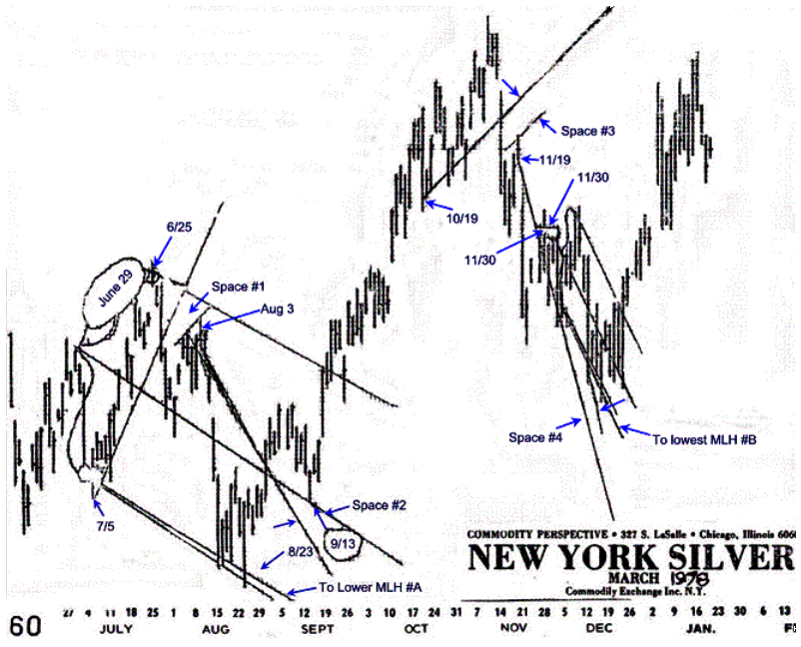
Study on Action and Reaction Lines: In this Course you should realise the importance of A-R lines. When a man who had made over $50,000,000 attributes his fortune to this principle that Action and Reaction are equal and opposite, you too will find that they can increase the odds enormously in your favor by knowing what they tell you. One reason you will make consistently large profits is because you will sell after rises and buy after declines. When one check the reason for past losses in stocks or futures, he invariably finds he has done just the opposite. To use this method, you measure the distance from a center line such as the 0-4 line shown here. In a rise you measure back to the top pivots in order to find an equal distance to future low pivots. You do this easily by drawing parallels as shown. The R1 line lets prices drop through before the price rallies back the next day to this line. When price drops through it indicates that the previous trend will continue. When as in this case the rally back to the line is small shows you that the prices will move lots more in the original direction to the next trend reversal at the next R line. In R2 prices gapped, a gap being a negative reversal. This fact was first shown in this Course. A gap is nearly always followed that same day or the next with a reversal or another gap.
One the trend line was crossed by the closing price on February 10th a short sale could have been made and held from 72 price to the present as prices continued to drop though every R line.

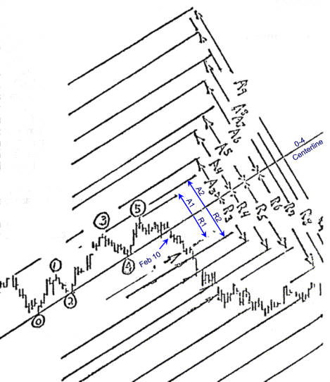

CASE STUDY COURSE ON PRICES
AND PROGNOSTICATION

ZERO TO THREE LINES: The weavers of "Meshes and Nets, Grid Matrix and Sets".
Pythagorus and members of his Courses taught that each combination of numbers had meaning other than that of a "Set" of numbers. As members of this Course you have seen that the 0-4 lines are useful to measure (A) and (R) lines from, and how 1-3 or 2-4 lines in SEP [skewed expanding pivot] are useful when prices cross them as profit makers.
This study reveals to you that these 0-3 lines no only are good lines to measure from, but they are unique in that there is a high mathematical probability that their (R) lines will pass through at least one P at the start of a new trend, and usually the P at the start and the P at the end of the move, whether the move be a long or short one.
Therefore the 0-3 line shows you what other investors would give a lot to know, viz., "how fast will the next drop (or rise) be, where will the start be and where will the end be."
For examples and proof refer to the enclosed Winnipeg Flaxseed Chart. You can start with line D as the #1 Centerline (CL) as it passes through Pivot 0 and P3. As one of several past Ps you can take the Gap, line C as 1(a)1, and take line A as another, 1(a)2. In this last example you notice that this lien passes not only through the usual low P that we measure to when prices have been dropping, but this line also passes through the top P where the drop started. You'll also note that line Z-Z at the extreme left of the chart passing through both top and bottom Ps enables you to sue it as an (a) lien about line A as a CL And it tells you to sell short on July 31 when line B turned down pries at 330. Line B was of course the corresponding (R) line to Z-Z.
So you now have another member of a "set" that you can use to measure from, as well as the 0-4 and 1-3 and 2-4, and other members of the "set".
As further examples of the marvelous order, a geometrical order that you are one of the few people in the world to know of its existence, is:

- since (A) and (R) are parallel the price trend at all (R)'s from 0-3 CLs are all parallel and all tend to pass through Ps at the top and bottom.
- each of these (A) and (R) lines can also be used as a reliable CL to indicate where future prices will change trend.

Now you should check all the other liens marked by capital letters of the alphabet with other (A) and (R) lines that you draw in yourself.
You will notice that you have a mesh of ascending and falling parallel lines that form a network along whose lines prices tend to rise and fall.

Alan H. Andrews, Director

You members will see that each of the three different positions shown here were taken by getting your orders in before the market opened at the price where it might possibly meet one of the Course lines in two cases. In the third case where the mini ML and its H line were used to signal the buy, you assumed that prices might rise above the H line so had your order in to buy at 197. Similarly where you used the (3) as a CL from which to measure back to a low P in order to get the probable distance to its corresponding High P, you see how high price would have to rise on 2/15 in order to meet R2, and you put your order in at that price. Similarly you'd see that 206.50 would reach 2/21/ ML.
This 0-4 CL tells you when to buy on this chart when you measure back to the distance of each top P to five you the same distance to the next low P. This is our famous Action & Reaction Rule that my late friend from MIT adapted from Newton's law of physics that "A" and "R" are equal and opposite, and on which Babson attributed his fortune of $50,000,000. If you only learned this one rule from this Course, you could become a millionaire also, as other people have. Each little circle is at the top P from which the A line is drawn. To get the place to sell you reverse and draw in another convenient 0-4 CL that slopes downward and now measure back to the low Ps for you're a line distance, and then draw the opposite R line. You have several places where you can draw this 0-4, such as the one we numbers and drew in for you. To avoid too many lines messing up the chart, you can get semi-transparent drafting sheets at office supply stores to put over your original chart.
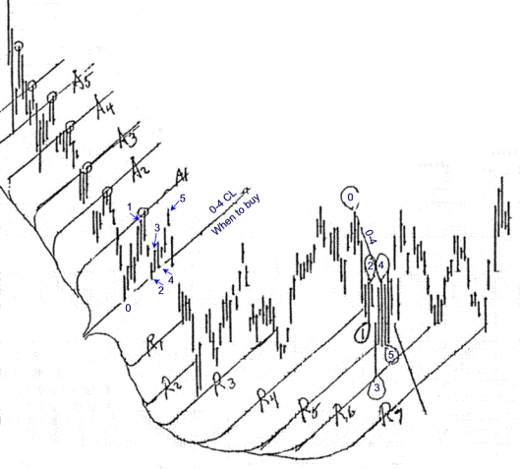

Course members who do a little chart work are making profits like those below, so get with it.
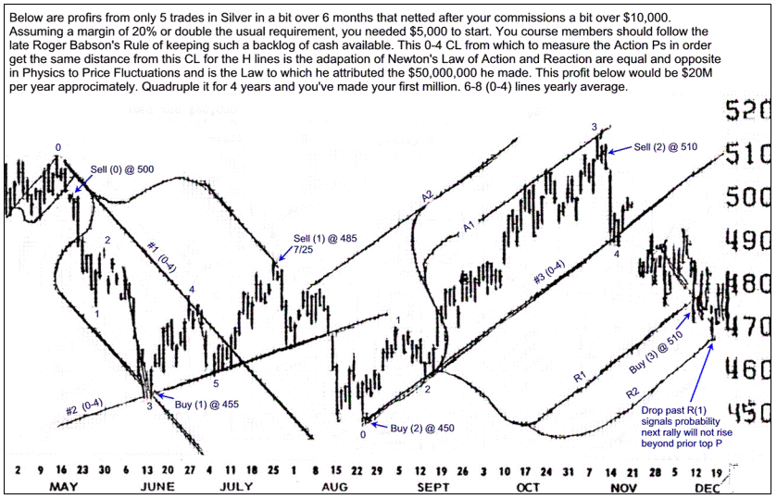
{AR 31}Another Action & Reaction Rule for price fluctuations is the (0 to 1) CL to measure action and reaction from. Remember the "equal & opposite" part of this Rule of the great Isaac Newton who discovered this rule in physics, and that my friend the late Roger Babson adapted to price fluctuations, and attributed his $50,000,000 fortune to. If you made $2000 each week for 50 years you'd have $50,000,000. These lines are started from the closes, whereas (0-4) lines start at the extreme of range.. Note that you have a high probability of profit by acting on each R line.
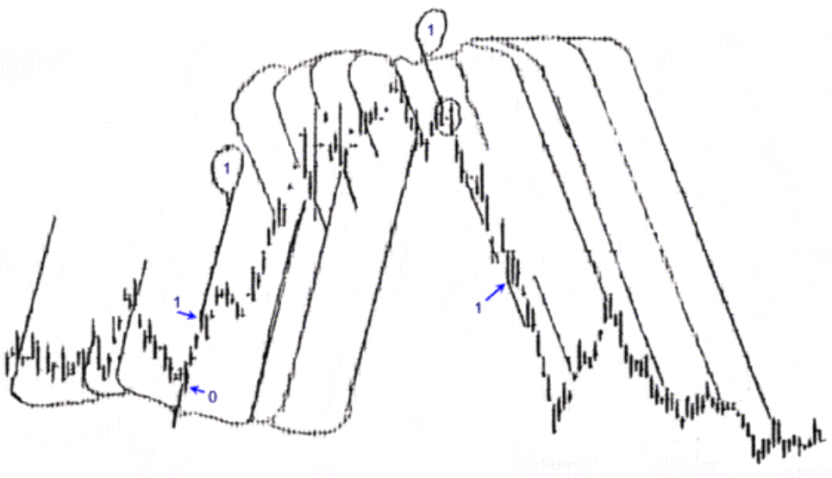
{AR 32}The dash line is a (3) to measure back to the top close for (A) distances as a CL to measure ahead to another parallel that is the (R) line where prices make a top. This alteration of the principle "Action & Reaction are equal and opposite" provides signals for additional Ps that are sometimes missed when we confine our lines to those Ps that are opposite.
The other two (3) lines use the opposite principle: The top (3) has no A nor R lines so that you can practice drawing them and see the profits you can be making after your paper trading shows you that you have mastered this.

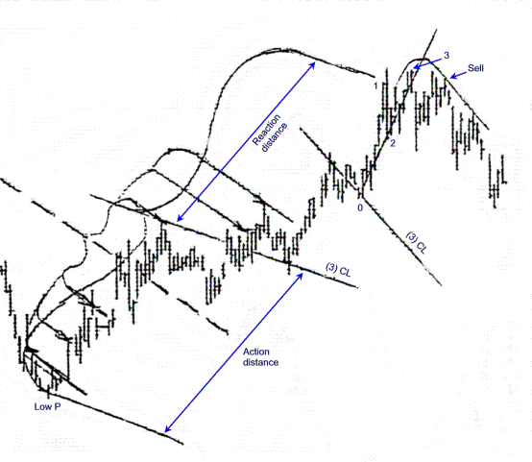
(0-4) is the Zero to Four line as a center line (CL) from which to measure the distance of the top pivot so you can measure an equal distance ahead or below for the reaction parallels each pointing to the low pivots from which prices will rise.
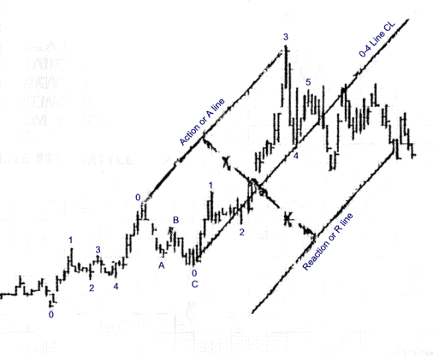
A drop from 97 to 37 in a bit over 1 year offered a potential profit of 60c. Each 10c drop showed a $5000 profit or enough to double the number of contracts held if margin was $5000 per contract. Therefore for each 10c drop in a 60c decline you find the number of contracts held is 32 if you started with one contract, and giving you two eks from profit on the first drop, 4 eks after the second drop, 8 after the next , etc. Of course the 10c in Mar & Apr in 74 would wipe you out if you had not sold at 70 area in �74R4, or at 62 area @ R6. But use DTRs on DT to keep selling and UTRs on UT to keep buying with part of your profit each time at least.
Not buy signal each time price rises from the left to meet the R line.
Note sell signal each time that prices fall to the right of each R.

It doesn't seem to matter when you can't decide which is the proper P4 when you draw your 0-4 to use as a CL in the Action-Reaction Rule for if you try them both as done here in September and again in December Treasury Bonds, the R lines point to lows from which good profits can be made except where there is a gap. But even with a gap prices will probably come back near it so loss could be small. Note how this A-R method works on Relative Strength Index and Weekly Range Charts.

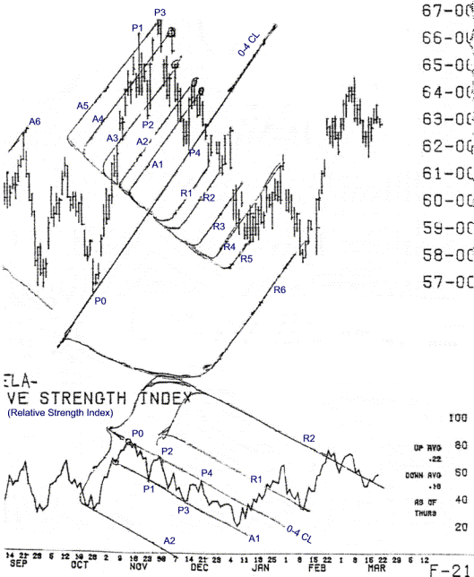

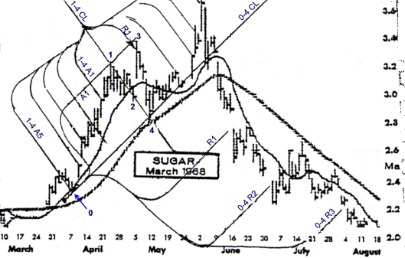

Case Study Course Example of Expanding Pivot Formation, of 0-4 line as a Center Line, and of 1-4 line as a Center Line (CL); also of the Moving Average lines as CL.
These are only three of the CLs that can be used to measure Action and Reaction (A) and (R) from. Other CLs are Median Lines, (ML); Multi-pivot lines, (MPL); Peak to Low, (P-L); (Note that this P-L is usually a 0-5 line). Also, such is the marvelous order of Price Fluctuations that you may use lines between any two Ps as CLs. Can you now see how this application of Newton's Law about Action and Reaction applied to prices, was the principle to which Roger Babson attributed his $50 million ?
First you should notice how Ps 1,3,5 are progressively higher while Ps 2&4 are points in a down sloping line giving you the E.P. Formation. You recall the E.P. Rule states that prices will drop at least that distance below the 0-4 line that they are previously above that line. Now if you had sold short near P5, you might put an order in to cover at 2.78 on June 17. But when prices gap and drop way below the R1 line on that day, you know from this that even though prices nearly always ally back toward that R line, they are seen going much lower. So you take your position accordingly, following the trend down until R2. Again drops below the price at which R2 intersects, signals another 100% drop as a high probability, to R3. Here you find the same signal. Remember that this continued drop to equidistant R1, R2, R3 is peculiar to the E.P. formation. Here only is the probability high that you can safely ride a long trend down by observing this phenomena which is meaningless to other investors who have not taken the Course. You may now start looking for the inverted E.P. on other charts as well as for this E.P. above.
Please note how you can use the 30 day M.A. lien together with the 10 day line to check how far probable declines will end. Here just consider the 30 day M.A. which on 4/24 the day of P1 closed about 60 points above the M.A. on that day. Similarly on the days of P4 and P5, about 60 points difference. Therefore you know there is a high probability that the drops on June 17 and July 6th, will be about the same distance of 60 points below the M.A. Line on that date. You get more accuracy in correspondence by measurement to the close usually than by measuring to the extreme of the range, for those days.

A.H. Andrews, Director � 1971

"BELIEVE IT OR NOT

You can learn here in this page of our Case Study Course, how to anticipate, for the months ahead, when to take profitable action in the stock market. You can do this be simple graphic mathematics. At the end of March, this chart gave you all the information you needed to make money in the stock market during the next seven months, by buying near the lows and selling near the high pivots. "here's How", so drink deep of the new revelations from this Fount of Wisdom.
You draw a Median Line (ML) as shown from 1 bisecting the distance between 2 and 3. Then draw another ML from b, bisecting the distance between these same pivots 2 and 3 again. One of our discoveries is that when prices meet one of these ML lines, the probability of a countermove starting at or near the meeting point is high. So whenever prices drop to meet the ML from b on the chart, and stop, you can buy with "impunity and abandon", figuratively. And when they rise to meet the ML from 1, you can sell.
Our next step is to use our Action-Reaction Method in combination with the above Median Line (ML) Method. So draw a Down Trend line (DTL) from the bottom of the range each week that a low pivot shows. We call these lines Action or A lines. And to the right of the SRL you draw other parallel lines, each equidistant from the DTL to its corresponding A line. We call these new lines Reaction Lines (RL), for when pries meet these lines in the future, they react downward, whereas the price rose from each of the corresponding Action or A lines in the past history as shown by our chart. So you Sell when in the future prices rise to meet these lines.
Now to see how these lines we drew actually work, loosen the rest of the chart from the back of this sheet and fold it over so you can see it from this side. You see that the ML from b told you to buy at 3, 5 and 7,& 9 and that the DTLs enabled you to sell at 4, 6, 8 pivots. This was always before a drop of enough percentage to give you a nice profit.
Next week our Case Study will enable you to apply our A-R lines so you will have still another method for knowing the right times to buy in contract to this weeks use of A-R lines showing when to sell.
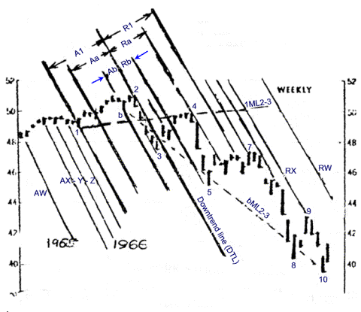

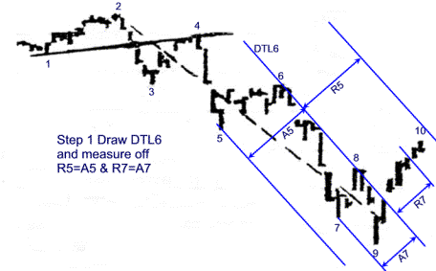
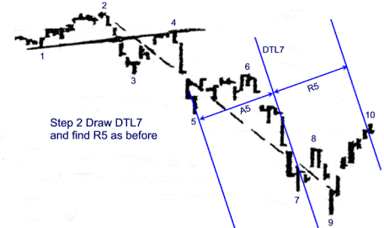
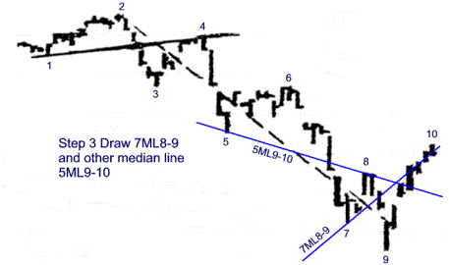

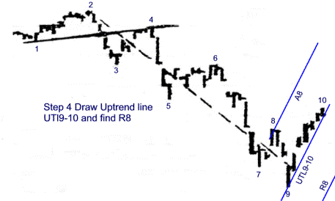
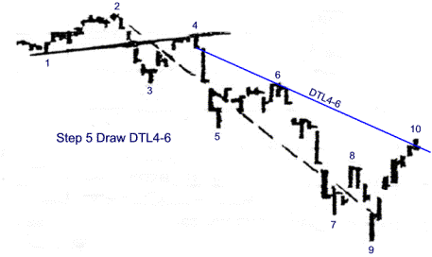
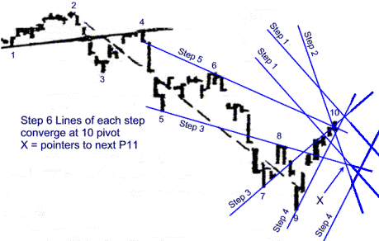

Professor Anderson's Five Pivot Rules original here

The late R. N. Elliot and John C. Sinclair of Francis I Dupont & Company were the first to point out that all bull markets are composed of five fluctuations, three up and two down during the rise, and a down -up-down formation during the correction, or counter move following the rise. Elliot's contention was that this followed a law of nature.
Your director has had pleasant and informative discussions with Mr. Clyde Morse, a former coworker with Elliot, and incidentally the grandson of Morse of telegraph fame. Mr. Morse stated that those apparent inconsistencies where there could be more than five trends counted were termed extensions by Elliot.
Professor Anderson's Rule differs from Elliot's in observing 5 P after the zero starting point for the first rise, and 5 P on the down trend before a down trend line is crossed by rising prices. On the enclosed charts you can see Elliot's 3 down moves indicated by a, b, c. But in nearly every case you can count 5 pivots after the 0-4 line has been penetrated before the next five Ps follow the crossing of the resulting trend line, and action taken.
The EP formation is a special case of the Five Pivot Rule. IT is special because it alone indicates a minimum drop where R equals A max in nearly every case as shown in the Oct '66 Copper, where the 0-4 line has been drawn in. You should draw in the other 0-4 lines for experience. And notice that on frequent occasions the drop after other rising 0-5 has been penetrated may be less than the farthest P above the 0-4 line. Also on very rare occasions this line may be penetrated temporarily, for a very short distance, before a new resumption of the original trend that continues until another 5 P has formed. The first of the above cases is shown in red on the Feb bellies chart. The second case of temporary penetration is on this same chart at P6 in August. The resulting "whip-saw" loss may usually be more than offset by prompt action when prices cross either the minor trend line from 5 to 6 in August, or the upward slanting line drawn through the 3 and 5 in July, as examples.
Eventually the extension of any 0-4 line will be crossed and will provide a good gain more than making up any of these rare whip-saw losses. (Shown by the October drop in Feb. Bellies chart)
The great Helmholtz wrote, "Of all branches of human knowledge there is none like geometry. It escapes the tedious and troublesome task of collecting experimental facts. The sole form of its scientific method is deduction". You have noticed that the morphological approach used in this Course employs simple geometry. It provides consistently unusual profits as long as its rules are acted on. As Helmholtz indicated it avoids the endless facts upon which fundamentalists base their approach toward price prediction.

Alan H. Andrews, Director

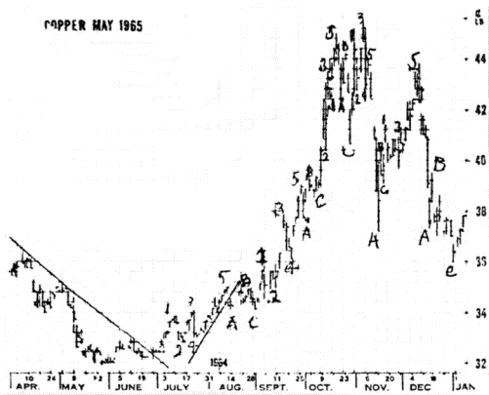

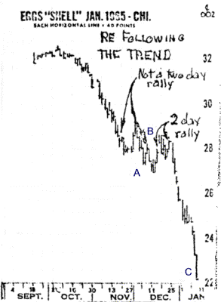

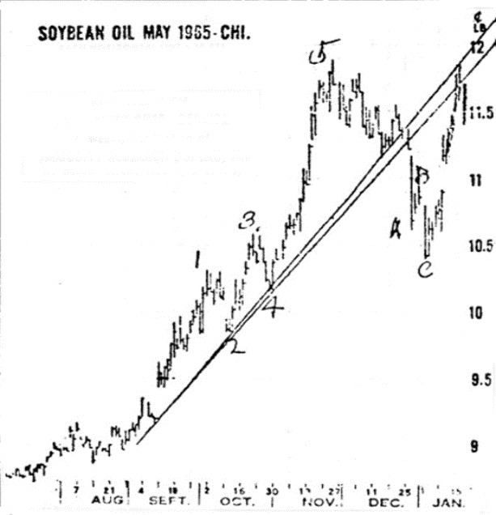

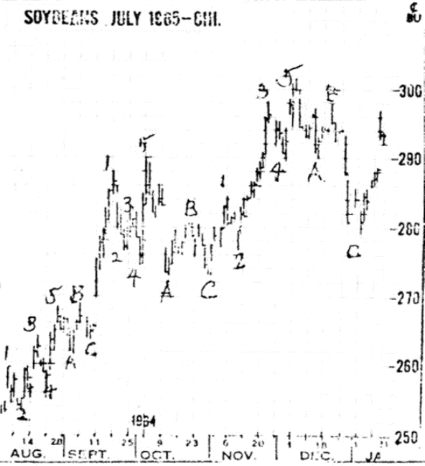

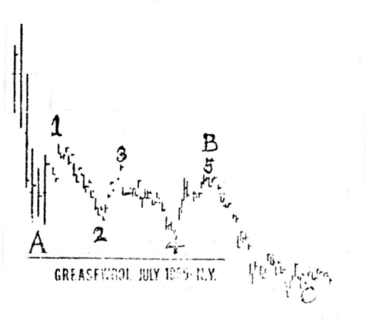

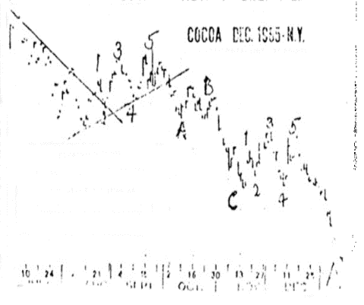

Professor Anderson's 5 Pivot Rule
Zero to Fourth Pivot Rule
Expanding Pivot Rule

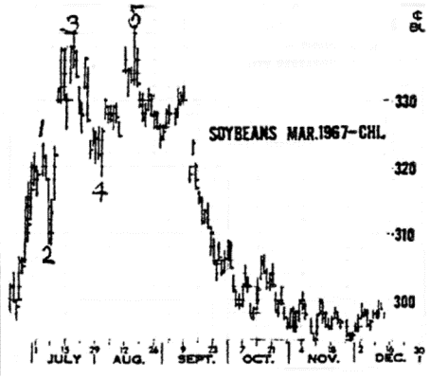

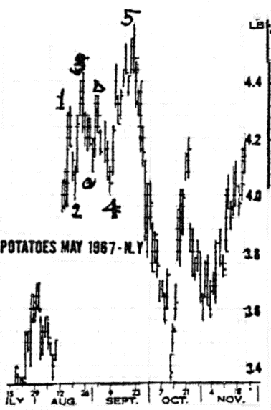

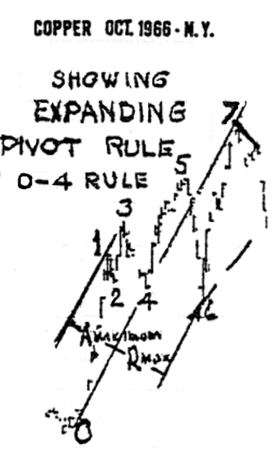

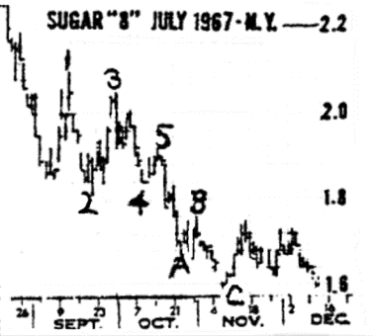

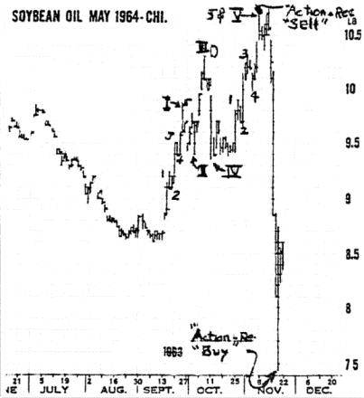

{AR 44 part d}

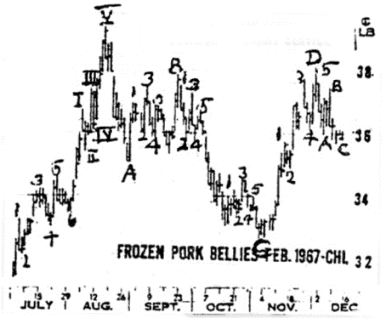

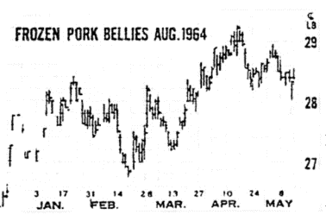

As soon as you draw your (0-3) as CL for A-R rule start as soon as possible to draw you're a lines through the top close of each real UT (up trend). Then as new ranges develop from day to day you see where prices will intercept the R lines if they fall to them that day. And if they pass through each or any R that shows the probability of new lows, beyond the recent ones.
What distinguishes the close used for the A line is, it is the close at the top of each fluctuation, with a UT before it and a DT following it.

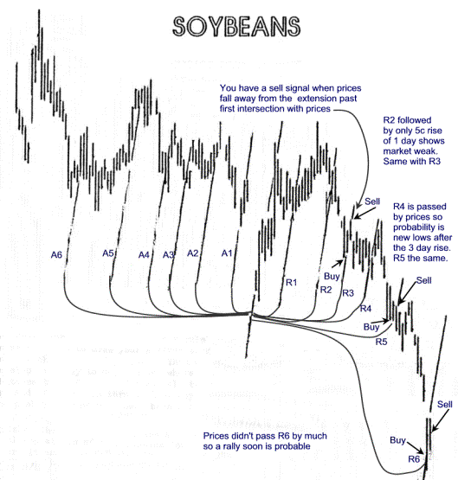

"God is a Mathematician"

If you drew in the (A) and (R) lines on May Soybean meal chart as suggested in previous study you see they looked like the lines on the lower left chart. As you notice, "Where lines converge with price, a pivot (P) is formed", an important Rule. Also note that the centerlines were all multi-pivot lines (MPL). Note that (A)6 above the MPL6 that slopes about 45 degrees had its corresponding (R) at the final low, but it was also the (R) above that MPL6 that was at the peak pivot.
The chart on the right [in this document it is the second chart below - Ed] shows that fluctuations during July and August enabled you to draw several MPL converging around Nov 22. The one with the most Ps was MMPL14. Lay over this the rib of a fan and note how price movement in September and October enabled you to slide your pivot finder along this MMPL14 until ribs O and P were over MPLs in those months. This located the center of the fan also near Nov 22.
As prices dropped along MMPL14 in July and August there were 4 rallies which enabled you to draw WMPL and similarly at W, Y, Z. Notice that the slope of these lines prognosticated a center around the November 15 low. And note that these lines fitted the 10 degree angles made by the ribs. This particular chart is of special interest in many ways. Particularly because the upribs pointed to a low. And these lines were indicated months before anyone dreamed that this Salad oil didn't exist as stated by the Salad Oil King. Does this fact show that there are no secrets in the world of mathematics that determined where the top and low peaks were to come?

{AR 47 part a}
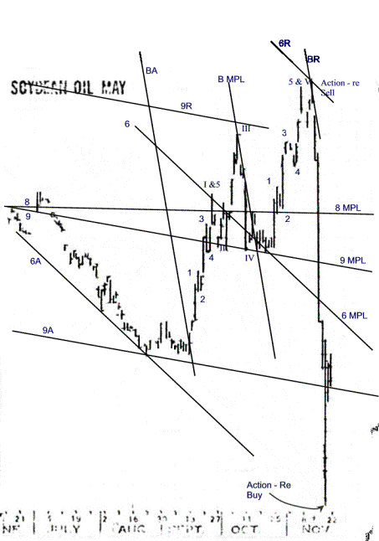

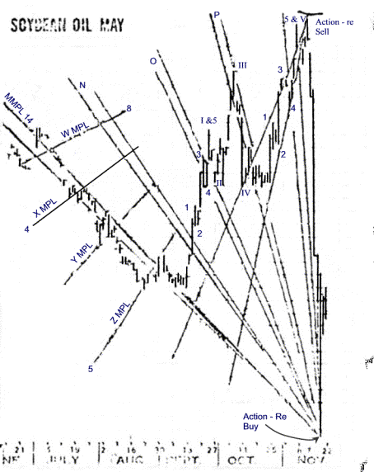
{AR 47 part c}
The Gold chart shows a similar pattern to that of Silver. Since this is a chart I used before there will be no explanation of the course lines that I had upon it. The lines should be apparent to you nevertheless. Since we are discussing EP's just note that activity within the semi-circle I have drawn. P1 was on Feb 23, P2 was on Feb 27, P3 was on Feb 27, P4 was on Mar 1, and P5 was on Mar 5. There are numerous other reasons for selling this market on Mar 5 to coincide with this EP. Most notably the 5 P's on the UT from 1-26 and the 11-17 ML 11-30/1-26. We certainly hope this helps in your study of course methods.

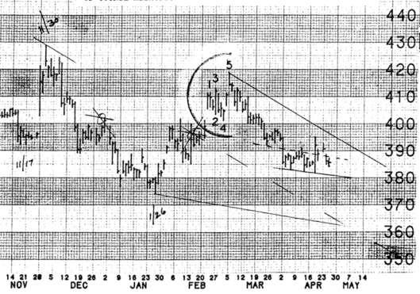
This cotton chart from July 1984 shows a classic EP formation. After a long rise from Feb 13 the market topped out with an EP. This is shown by the circled numbers at each P. NO discussion is made of the other lines as they were already on the chart from my previous trading.
The dates for the P's are: P1 Mar 12, P2 Mar 19, P3 Mar 21, P4 Mar 27, P5 Apr 2.

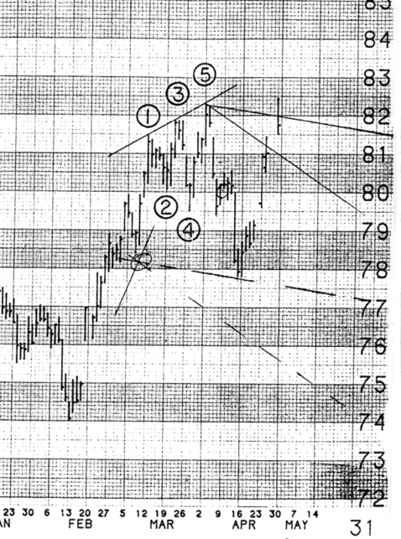
}I went back and found some older 1984 charts that I had remembered using for trades and have included them in this letter for our discussion of EP's. This silver chart shows a good example of an EP, contained within the half circle, and numbered from one to five. Just so there will be no confusion whatsoever I am including the dates of the P's so you can follow along.
P1 was on Feb 23, P2 was on Feb 27, P3 was on Feb 27, P4 was on Mar 1, P5 was on Mar 5.

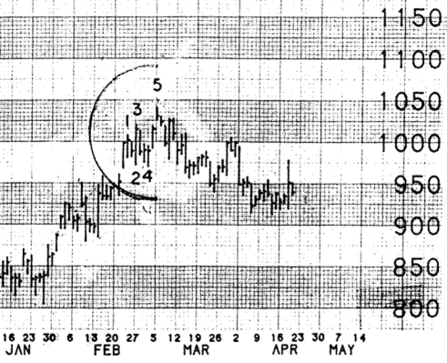
FFES Letter for the week of January 7, 1985
There was no letter last week due to the holiday and shortened trade week.
Just another reminder to those who have not sent in their $25 and still wish to receive the weekly letters.
First of all there was an error in the sugar chart comments in the 12/24/84 letter. Please correct line two (down from the top) to read: "Evident when considering that the last ML of any significance that was reached by price action was." This should make a great deal more sense to the intent of the comments.
For those members sending in questions for the professor to answer please follow these instructions. Leave an adequate amount of space on your chart or on your paper after the question for its answer.
We have had a few inquiries about option pamphlet information from subscribers. If you would like we will have our broker send you some information, just send us a note requesting this information.
Because of some of the questions sent in about our discussion of expanding pivots (EP's) and skewed expanding pivots (SEP's) we are going to devote this whole letter to their discussion and presentation. We had assumed that all of our members were familiar with these formations and their import upon market action that tends to follow their appearance. First, the expanding pivot is a situation where the market makes a pivot, then a lower P, then a P higher than at P1, next a P lower than at P2, and finally a P higher than at P3. This is shown schematically at the bottom of the page. A SEP is similar in that the P's swing wider but no new lows are made, only the size of the swings increase, This is also shown schematically. Note that P3/4 is greater than P1/2 and P4/5 greater than P2/3.

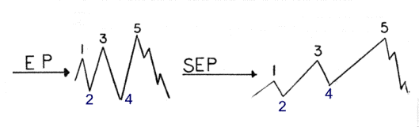
Cocoa could not make the 9-11 ML 9-24/10-4 and falls to 9-24 ML 10-4/11-13
The 8-1 MPL 10-18 can be a CL to measure A & R. A is at 8-30/9-24 and R is down at this equidistance.
10-4 could be P1, 11-13 P2, and we are falling down to a P3 at 9-24 ML 10-4/11-13 or possibly to its MLH with a possible P3 at the R line.

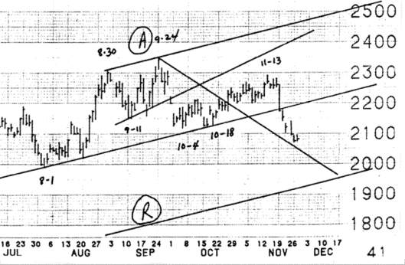
Coffee contract
1 - Major 2P line from 5-23 to 8-31
2 - Market too weak to rise to 2P line and the 7-30 ML 8-31/10-1
3 - the 8-31 ML 10-1/11-13 points down steeply as does the 9-17 Schiff ML 10-31
4 - probability is for lower prices than at 132 on 10-1
5 - note the 5P's up from 10-29 to 11-13 before a price reversal

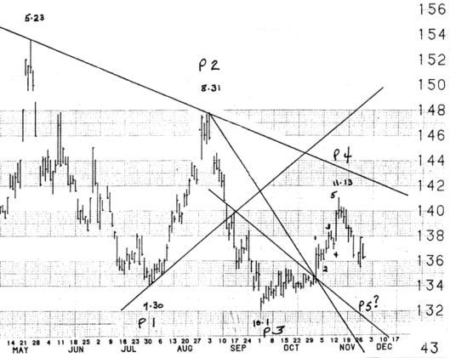
Wheat gave 5 major P's on DT from May 25
A new UT started on 10-5 and prices rose to the 7-25 ML 8-3/10-5 where 5 minor P's were made before a reversal down close to the 8-3 ML 10-5/11-6.
If the space at 11-15 holds then prices probably are going higher than at 11-6 on their way to a P3 at the 105 ML 116/1115.

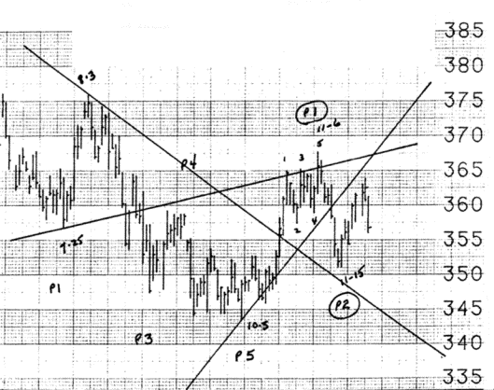
Soybeans are making a P5 of the DT that began 11-1.
Note that the 9-4 Schiff ML 10-5 called the P3 reversal on Nov 28 and is basically containing the downside of price action so far. The 11-12 ML 11-28/12-3 probably will call the P5 in the 600 area.
If this probable market action occurs than this should be the start of a new up trend. Also note that the MLH of the 11-12 ML has been the overhead resistance to prices so far, that is the sliding MLH.

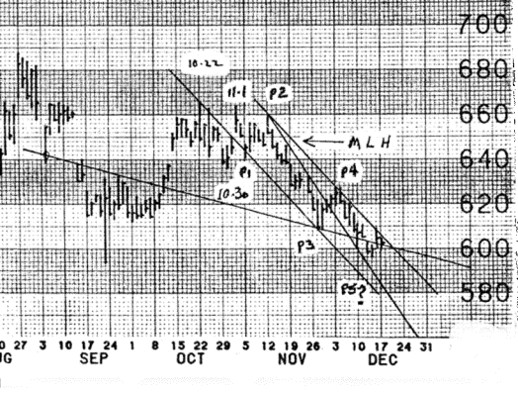
After 5 P's of UT from Dec 7 we have made 5 P's down from 11-23 to the 10-11 ML 10-22/11-23.
The probability is for prices to now rise to the 10-22 ML 11-23/12-4 before a reversal. Please note that the overall trend is still up so we should expect higher prices after a small reversal. Note the 0 ML 1-2 calling P5 of UT and its MLH showing the point to sell after this rise.

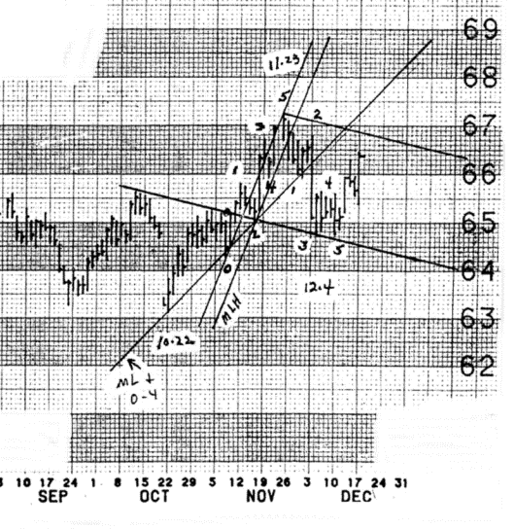
Orange Juice had broken the neckline of a significant head and shoulders formation as noted (H for head and S for shoulders). Prices are in a steep drop along the 9-21 ML 10-30/11-26. The H&S projects to 144. If we use the 7-12 2P 10-30 as a CL to measure A & R we note the A line drawn H to CL at 9-21 high to give us our R objective at 146. It may be hard to believe that O J, going into the potential freeze season, projects to this low area, but that is the current probability.
Remember the course axiom the steeper the ML the faster the price action.
(R line not shown as off the chart)

